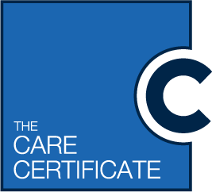

Invitation to A Care Certificate Assessor Workshop/ Assessment day
The Care Certificate is a set of standards that anyone delivering care to people in a health or social care setting are required to comply with. Many organisations deliver their own Care Certificate training as part of a routine induction process. Oxfordshire County Council and partner organisations want to help to improve the work-based assessment side of the Care Certificate, following an initial workshop with provider agencies. The training below is a pilot for care homes and home care (for elderly people) and primary care.
Who is this day aimed at?
All staff with responsibilities for the delivery or assessment of the Care Certificate in order to:
- Increase understanding of the Care Certificate standards
- Ensure knowledge and assessment meets the pilot standard within Oxfordshire
- Awareness of available resources
- Help breakdown the common barriers to assessing across the sector
- Busting commonly held myths
- Working with like- minded colleagues to set an agreed minimum standard for assessing across all sectors
- Trial some practice assessment tools
There are 50 places available, 25 at each of the two venues for those who are keen to be part of this pilot assessor training day which has been designed and devised by stakeholders within the sector.
Two sessions will be held from 9.45am until 4pm (Refreshments and lunch are provided):
Date: | Location: | Region:
23rd July 2019 | Sandford Village Hall, Littlemore | South Oxfordshire
25th July 2019 | Lincroft Care Home, Kidlington | North Oxfordshire

To book a place on this day please email looblackburn@nhs.net or ring 07903 552363 by 19th July. Places will be given on a first come first served basis.

Testimonials from initial workshop:

‘Have learned so much from this session, will go back and discuss with manager re updating our approach’

‘This is what the sector needs, sharing our best practice, now so much better informed about the delivery and assessment process’

‘A standardised approach definitely sought after’

‘We have been able to issue so many of our staff with a Care Certificate now as I wasn’t aware I could simulate some of the assessment’

‘Really want to continue to be part of the pilot as there are benefits to all staff and our assessor’
‘Would recommend all managers attend this as well as assessors, my knowledge greatly enhanced thank you’

