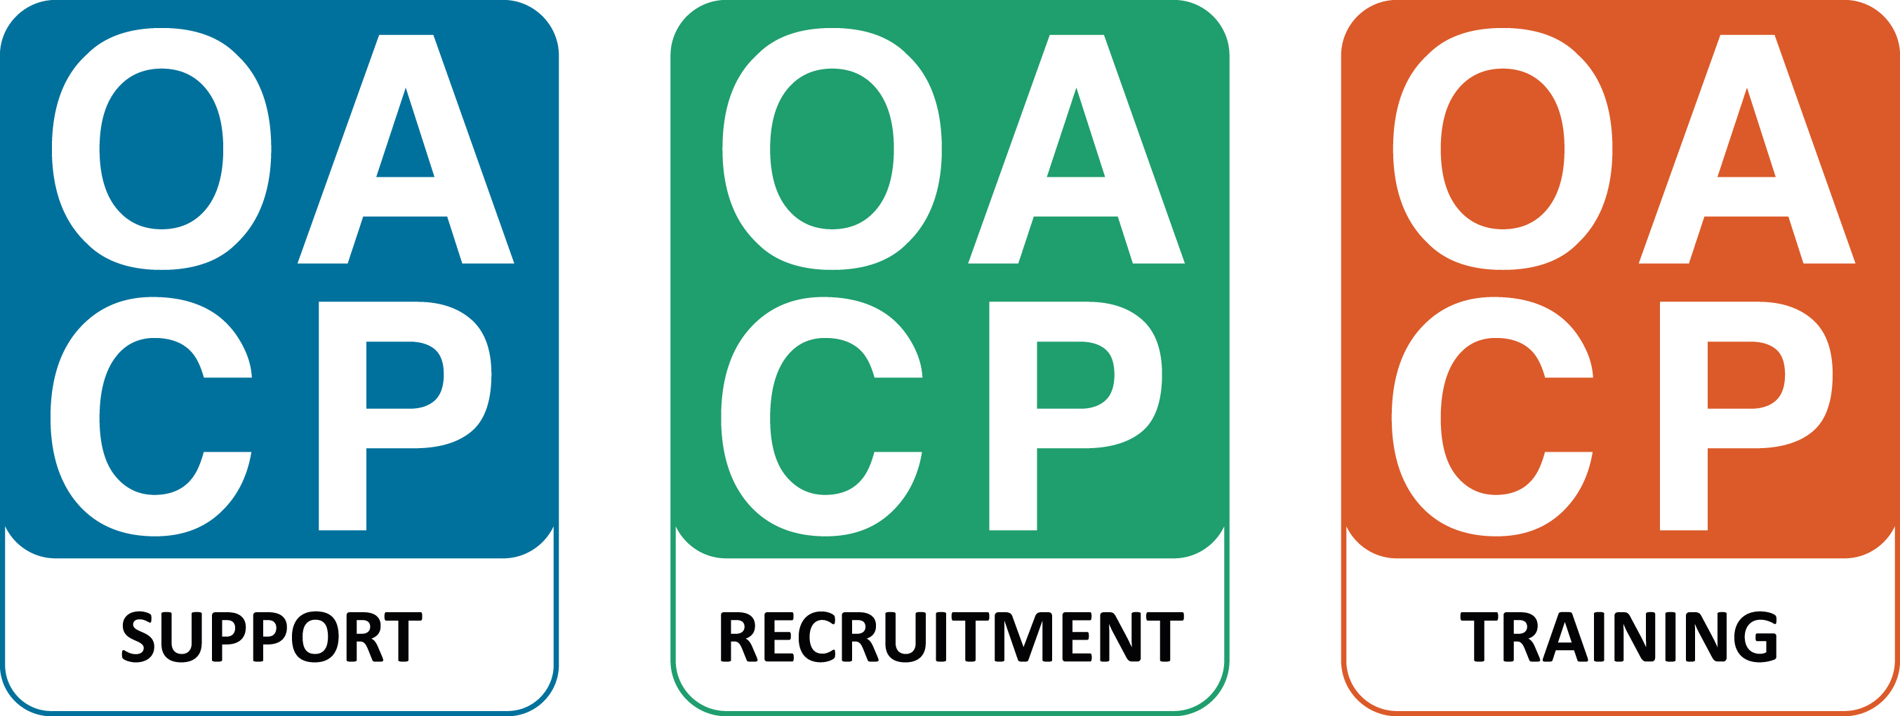
Make A Difference Everyday
Oxfordshire Care Awards 2018 Nomination Form
One entry form per nomination. All fields must be completed.
Category of Award being entered (please tick one only)
Newcomer to Care Award |  | Care Home Worker Award
Care Employer Award |  | Home Care Worker Award
Registered Manager Award |  | Community Services Worker Award
Oxfordshire Hero Award
Name of person completing this form
Name of Nominee
Name of Nominee’s employer
Is the person completing this form…
- A colleague?
- Related to the Nominee?
- A client of the Nominee?
- Other relationship (please specify)
Have you informed the Nominee of their nomination? |  |  |  | Yes |  | No
Statement of nomination (maximum of 400 words)
Your statement should describe why you think the Nominee should win the Award. Please refer to the Judging Criteria on the Entry Guidance.
No other supporting materials will be considered except testimonials.
An additional typed testimonial from a colleague and/ or/ service user and/ or/ family carer (maximum 1 A4 sheet per testimonial) is desirable.
Please make sure that the name of the Nominee, their Employer and the Award Category is included on all supporting information.
Attach all pieces of supporting information to this entry form and post to:
OACP | 9/ 10 Napier Court | Barton Lane | Abingdon | OX14 3YT

Or send by email to: jane.wood@oacp.org.uk. We will acknowledge all submissions.
Deadline for Nominations: 4pm, Friday 9th March 2018
Any nominations received after this time will not be considered or acknowledged.
Statement of nomination (maximum of 400 words)

