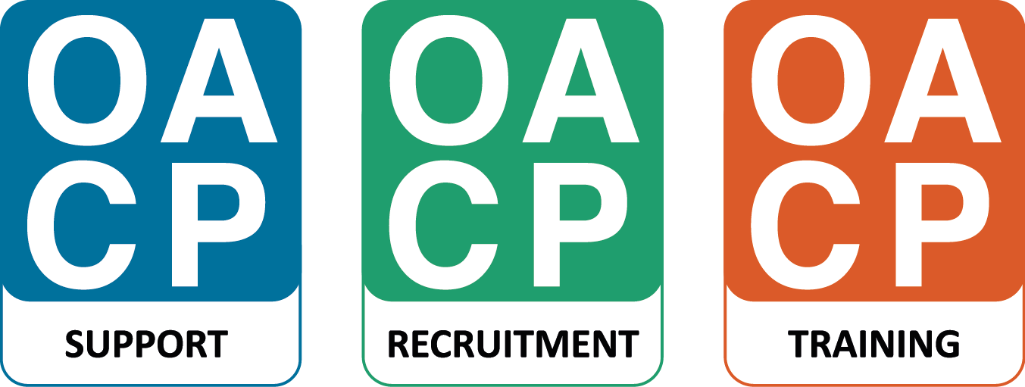

Care Home Providers Forum: 9.00 - 1.00
Thursday 13 June 2019

Westgate House, Millington Road Wallingford Oxfordshire OX10 8FE
(with thanks to Orders of St John)
Parking is limited. Please park on surrounding roads or car share where possible.
Please go to reception on arrival.

AGENDA (timings and topics may be subject to change)

9.00 Welcome: Eddy McDowall (OACP)

9.15 OCC update:

Simon Brown – Strategic Commissioning Manager (Oxfordshire County Council & Oxfordshire Clinical Commissioning Group) - Future OCC contracting intentions
Anna Mwiluki – Quality & Contracts Manager - PAMMS (Provider Assessment & Market Management Solution)
Amy Allen - MCA and DOLS Team Manager- Liberty Protection Safeguards
11.00 Break

11.15 NHS Digital: NHSmail
Update

12.00 Updates
- Meds errors - discussion

12.55 AOB

Future meeting dates

