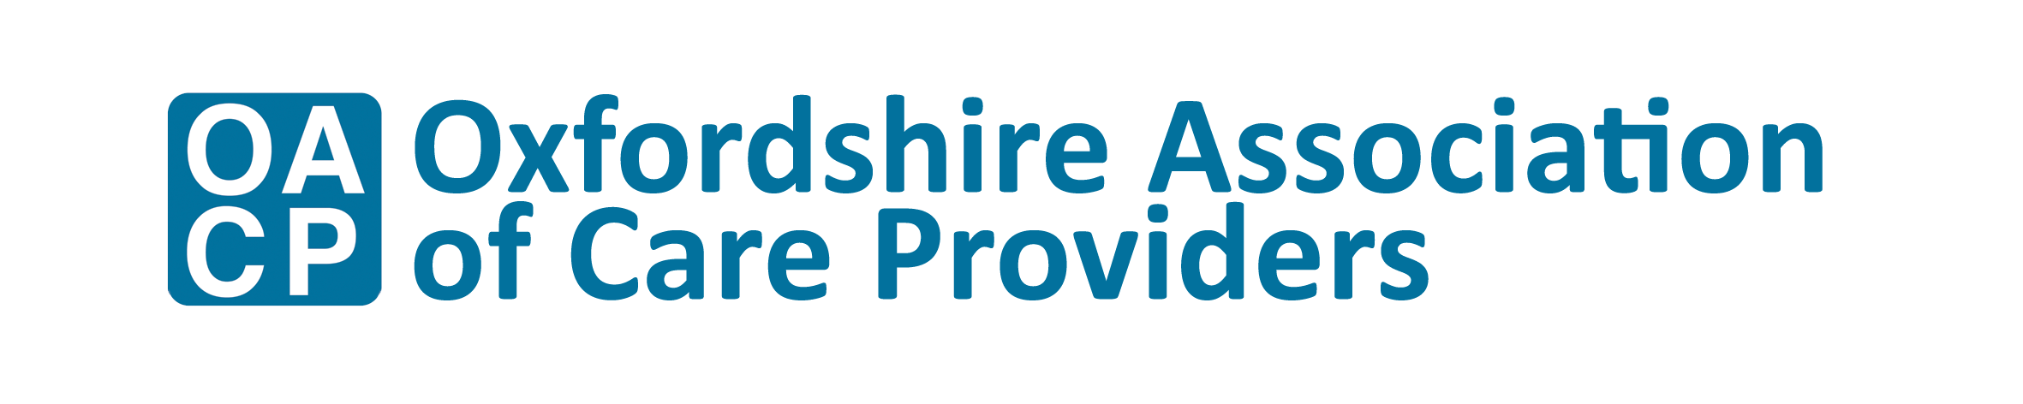

Oxfordshire Social Care Awards 2019

We are pleased to announce the third Oxfordshire Social Care Awards – the only care awards that recognise and celebrate adult social care in our County. Despite the challenges faced by social care, there is much to celebrate.

Adult social care in Oxfordshire performs better than the national average. The number of registered care providers rated as Outstanding by the Care Quality commission is increasing. The quality of care is rising across all parts of the sector. Non-registered care providers continue to provide essential services to support people in preventative services, despite the challenging economy social care operates in.

As the local sector leader, OACP encourages all providers, big and small, to take the time to nominate outstanding individuals within their services, who are making a difference every day, to people they care for and support.

There are eight categories in which to enter employees and one category for an outstanding provider. Entries will be judged by a panel of family carers and professionals working in or alongside the sector. Winners will be announced on 22nd March at Kassam Stadium.

It’s important that social care has a regular opportunity to celebrate the fantastic work it does day in and day out. We know that there are some amazing people, companies and organisations working in Adult Social Care in Oxfordshire, and we want to shine a spotlight on them.

Let’s celebrate social care together.

Eddy McDowall

Chief Executive

Oxfordshire Association of Care Providers